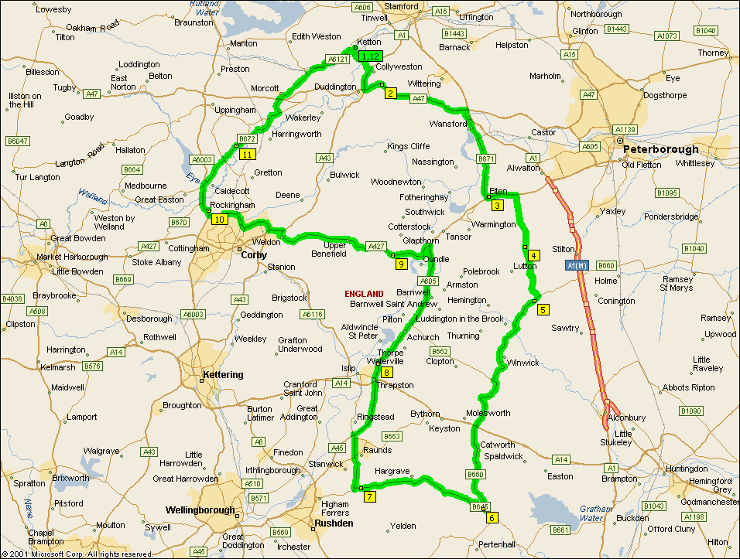

Summary: 79.9 miles (2 hours, 43 minutes)
Time | Mile | Instruction | For | Toward
09:00 | 0.0 | Depart Ketton on Local road(s) (West) | 54 yds
09:00 | 0.1 | Turn LEFT (South) onto Local road(s) | 43 yds
09:00 | 0.1 | Bear RIGHT (South) onto Local road(s) | 174 yds
09:00 | 0.2 | Turn LEFT (South) onto Local road(s) | 76 yds
09:01 | 0.2 | Bear RIGHT (South-West) onto Local road(s) | 87 yds
09:01 | 0.2 | Turn LEFT (South) onto Station Road | 0.2 mi
09:02 | 0.4 | Continue (South-East) on Local road(s) | 109 yds
09:03 | 0.5 | Bear LEFT (East) onto Local road(s) | 98 yds
09:03 | 0.6 | Turn RIGHT (South) onto Local road(s) | 0.4 mi
09:05 | 1.0 | Continue (East) on Ketton Road | 0.5 mi
09:07 | 1.5 | Bear LEFT (East) onto Back Lane | 0.2 mi
09:08 | 1.7 | Turn RIGHT (South) onto A43 [Main Road] | 1.1 mi
09:10 | 2.8 | At roundabout, take the FIRST exit | 10 yds
09:10 | 2.8 | Exit roundabout onto A47 | 0.9 mi
09:11 | 3.7 | At A47, stay on A47 (East) | 4.5 mi
09:18 | 8.2 | Turn RIGHT (South) onto A6118 [Old North Road] | 0.5 mi
09:20 | 8.8 | Continue (South) on B671 [Elton Road] | 4.2 mi
09:28 | 13.0 | Bear LEFT (East) onto A605 | 109 yds
09:28 | 13.0 | Turn LEFT (North) onto Local road(s) | 120 yds
09:29 | 13.1 | At Elton, return South on Local road(s) | 120 yds
09:29 | 13.2 | Turn LEFT (East) onto A605 | 1.4 mi
09:32 | 14.5 | Turn RIGHT (South) onto Bullock Road | 2.7 mi
09:40 | 17.2 | At 5 Bullock Rd, Washingley, Peterborough PE7 3, stay on Bullock Road (South) | 2.7 mi
09:49 | 20.0 | Turn RIGHT (South-West) onto B660 | 0.3 mi
09:50 | 20.3 | At B660, Great Gidding, Huntingdon PE175, stay on B660 (West) | 12.6 mi
10:13 | 32.8 | Turn RIGHT (West) onto B645 [Tilbrook Road] | 0.1 mi
10:13 | 33.0 | At B645, Kimbolton, Huntingdon PE180, stay on B645 [Tilbrook Road] (North-West) | 6.7 mi
10:25 | 39.6 | At B645, Chelveston, Wellingborough NN9 6, stay on B645 [Kimbolton Road] (West) | 0.4 mi
10:26 | 40.0 | Continue (North-West) on B663 [High Street] | 1.7 mi
10:30 | 41.7 | Continue (North) on London Road | 0.9 mi
10:32 | 42.6 | Continue (North) on B663 | 0.1 mi
10:33 | 42.7 | At roundabout, take the THIRD exit | 109 yds
10:33 | 42.8 | Exit roundabout onto A45 | 2.9 mi
10:37 | 45.7 | At roundabout, take the SECOND exit | 0.1 mi
10:37 | 45.8 | Exit roundabout onto A605 | 0.2 mi
10:38 | 46.0 | At roundabout, take the SECOND exit | 54 yds
10:38 | 46.0 | Exit roundabout onto A605 | 0.7 mi
10:39 | 46.8 | At A605, stay on A605 (North) | 6.7 mi
10:49 | 53.4 | At roundabout, take the FIRST exit | 10 yds
10:49 | 53.4 | Exit roundabout onto A427 [Station Road] | 2.2 mi
10:54 | 55.7 | At A427, stay on A427 [Benefield Road] (West) | 6.7 mi
11:06 | 62.3 | At roundabout, take the FIRST exit | 10 yds
11:06 | 62.3 | Exit roundabout onto A43 | 0.6 mi
11:07 | 63.0 | At roundabout, take the THIRD exit | 98 yds
11:07 | 63.0 | Exit roundabout onto A6116 [Steel Road] | 0.4 mi
11:08 | 63.4 | At roundabout, take the FIRST exit | 21 yds
11:08 | 63.4 | Exit roundabout onto A6116 [Steel Road] | 1.1 mi
11:11 | 64.6 | At roundabout, take the THIRD exit | 65 yds
11:11 | 64.6 | Exit roundabout onto A6116 [Phoenix Parkway] | 1.7 mi
11:14 | 66.3 | At roundabout, take the SECOND exit | 43 yds
11:14 | 66.3 | Exit roundabout onto A6116 [Gretton Brook Road] | 174 yds
11:14 | 66.4 | At roundabout, take the SECOND exit | 43 yds
11:14 | 66.4 | Exit roundabout onto A6116 [Rockingham Road] | 0.5 mi
11:15 | 66.9 | At roundabout, take the SECOND exit | 54 yds
11:15 | 67.0 | Exit roundabout onto A6003 | 0.1 mi
11:16 | 67.1 | Turn RIGHT (East) onto Local road(s) | 153 yds
11:16 | 67.2 | At Rockingham, return West on Local road(s) | 153 yds
11:17 | 67.3 | Turn RIGHT (North) onto A6003 | 1.7 mi
11:20 | 69.0 | Bear RIGHT (North-East) onto B672 [Lyddington Road] | 2.4 mi
11:24 | 71.4 | At B672, stay on B672 (East) | 3.7 mi
11:31 | 75.0 | Turn RIGHT (East) onto Local road(s) | 87 yds
11:32 | 75.1 | Bear LEFT (North-East) onto A6121 [Stamford Road] | 4.3 mi
11:40 | 79.4 | Turn RIGHT (South-East) onto Church Road | 0.2 mi
11:42 | 79.6 | Turn LEFT (East) onto Local road(s) | 87 yds
11:42 | 79.7 | Bear LEFT (North) onto Local road(s) | 76 yds
11:42 | 79.7 | Turn RIGHT (East) onto Local road(s) | 174 yds
11:42 | 79.8 | Bear LEFT (North) onto Local road(s) | 43 yds
11:43 | 79.8 | Turn RIGHT (East) onto Local road(s) | 54 yds
11:43 | 79.9 | Arrive Ketton

SUMMARY
Driving distance: 79.9 miles
Trip duration: 2 hours, 43 minutes
Driving time: 2 hours, 43 minutes
Cost: £9.88

