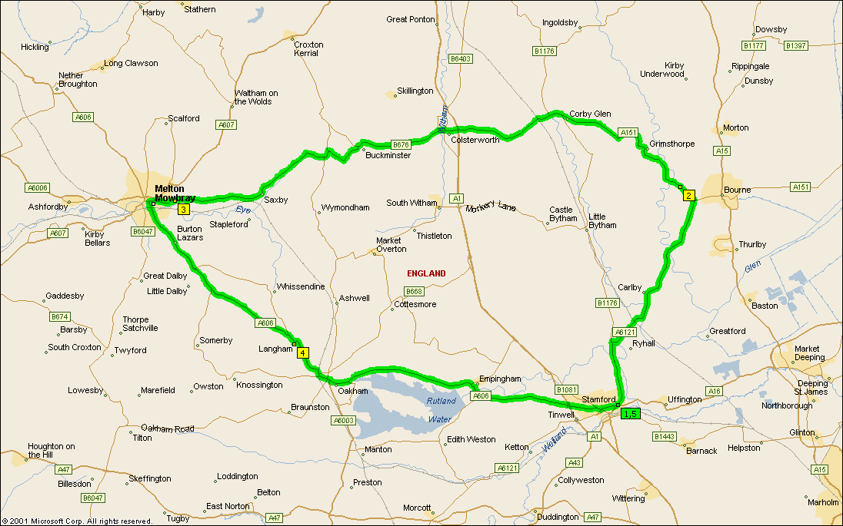

Summary: 54.9 miles (1 hour, 42 minutes)
Time | Mile | Instruction | For | Toward
09:00 | 0.0 | Depart Stamford on A6121 [Ryhall Road] (North-East) | 9.1 mi
09:18 | 9.1 | Bear LEFT (North-West) onto A151 | 0.7 mi
09:19 | 9.8 | At A151, Bourne PE100, stay on A151 (West) | 10.4 mi
09:37 | 20.2 | At roundabout, take the SECOND exit | 54 yds
09:37 | 20.2 | Exit roundabout onto B676 [Bourne Road] | 12.2 mi
09:59 | 32.4 | At B676, Melton Mowbray LE131, stay on B676 [Saxby Road] (West) | 0.7 mi
10:02 | 33.2 | Turn LEFT (South-West) onto Local road(s) | 10 yds
10:02 | 33.2 | Bear RIGHT (West) onto A606 [Thorpe End] | 8.6 mi
10:16 | 41.8 | At A606, stay on A606 [Main Road] (South) | 12.4 mi
10:39 | 54.2 | Turn LEFT (North) onto A6121 [North Street] | 0.5 mi
10:41 | 54.7 | Continue (East) on A16 [St Pauls Street] | 0.1 mi
10:42 | 54.8 | Continue (North-East) on A6121 [Ryhall Road] | 98 yds
10:42 | 54.9 | Arrive Stamford

SUMMARY
Driving distance: 54.9 miles
Trip duration: 1 hour, 42 minutes
Driving time: 1 hour, 42 minutes
Cost: £6.85

