Stamford – Grantham – Melton – Bourne – Stamford Loop

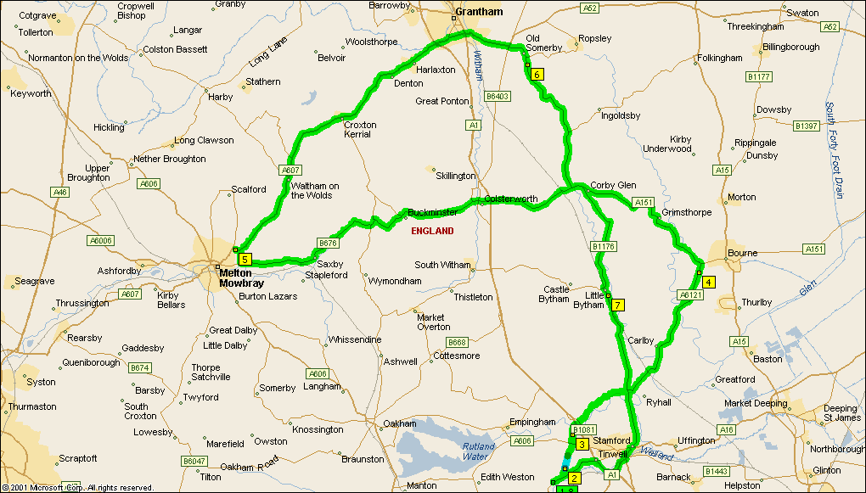
Summary: 77.0 miles (2 hours, 31 minutes)
Time | Mile | Instruction | For | Toward
09:00 | 0.0 | Depart 16 A6121, Ketton, Stamford PE9 3 on A6121 [High Street] (East) | 0.5 mi
09:01 | 0.5 | Turn LEFT (North) onto Steadfold Lane | 0.4 mi
09:02 | 0.9 | At Steadfold Lane, Stamford PE9 3, stay on Steadfold Lane (North) | 0.5 mi
09:04 | 1.4 | Continue (North) on Local road(s) | 0.5 mi
09:06 | 1.9 | Bear LEFT (North) onto Local road(s) | 142 yds
09:07 | 1.9 | Turn LEFT (West) onto A606 [Stamford Road] | 54 yds
09:07 | 2.0 | Turn RIGHT (North) onto Local road(s) | 0.3 mi
09:08 | 2.3 | At near Great Casterton, stay on Local road(s) (North) | 0.7 mi
09:11 | 3.0 | Bear LEFT (North-East) onto Ryhall Road | 1.6 mi
09:16 | 4.6 | Bear LEFT (North-East) onto Local road(s) | 0.9 mi
09:20 | 5.5 | Turn RIGHT (East) onto B1176 | 21 yds
09:20 | 5.6 | Turn LEFT (North-East) onto A6121 [Turnpike Road] | 6.3 mi
09:32 | 11.9 | At A6121, Bourne PE100, stay on A6121 (North) | 0.4 mi
09:33 | 12.2 | Bear LEFT (North-West) onto A151 | 11.1 mi
09:53 | 23.3 | At roundabout, take the SECOND exit | 54 yds
09:53 | 23.3 | Exit roundabout onto B676 [Bourne Road] | 12.0 mi
10:15 | 35.4 | Turn RIGHT (North) onto Lag Lane | 0.6 mi
10:17 | 35.9 | Turn LEFT (South-West) onto A607 | 0.2 mi
10:17 | 36.1 | At A607, Thorpe Arnold, Melton Mowbray LE144, return East on A607 | 13.6 mi
10:39 | 49.7 | Turn RIGHT (East) onto B677 [Springfield Road] | 0.7 mi
10:41 | 50.4 | Bear RIGHT (East) onto A52 [Bridge End Road] | 2.0 mi
10:44 | 52.4 | At roundabout, take the SECOND exit | 87 yds
10:44 | 52.4 | Exit roundabout onto B1176 | 1.3 mi
10:46 | 53.7 | At B1176, Old Somerby, Grantham NG334, stay on B1176 (South) | 6.1 mi
10:58 | 59.9 | Turn LEFT (East) onto A151 [Station Road] | 0.5 mi
10:59 | 60.3 | Turn RIGHT (South) onto B1176 [Swinstead Road] | 5.3 mi
11:09 | 65.6 | At 24 B1176, Little Bytham, Grantham NG334, stay on B1176 [Station Road] (South) | 4.2 mi
11:17 | 69.8 | Turn RIGHT (South) onto A6121 | 2.5 mi
11:23 | 72.3 | Continue (South-West) on A16 [St Pauls Street] | 0.5 mi
11:24 | 72.8 | Turn LEFT (South) onto A43 [High Street St Martins] | 1.2 mi
11:26 | 74.0 | Turn RIGHT (North-West) onto Ramp | 174 yds
11:26 | 74.1 | Bear LEFT (West) onto A1 [Great North Road] | 0.7 mi
11:27 | 74.8 | Bear LEFT (West) onto Ramp | 0.2 mi | A6121 / A47 / Stamford / Leicester
11:27 | 75.0 | Turn LEFT (West) onto A6121 [Tinwell Road] | 2.1 mi
11:31 | 77.0 | Arrive 16 A6121, Ketton, Stamford PE9 3

Start and end point is the car park of the Northwick Arms, High St, Ketton
SUMMARY
Driving distance: 77.0 miles
Trip duration: 2 hours, 31 minutes
Driving time: 2 hours, 31 minutes
Cost: £9.41

